Amber Bygrave – Brown
International Development with Politics
University of East Anglia
Encouraging social and economic growth among girls and women
AHO PLAN OF ACTION ON GIRLS AND WOMEN EMPOWERMENT
Partners

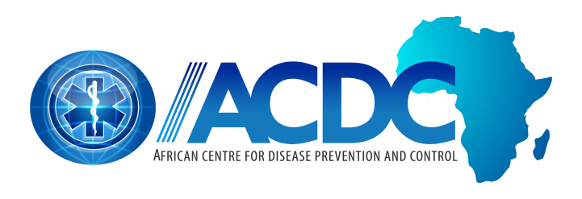

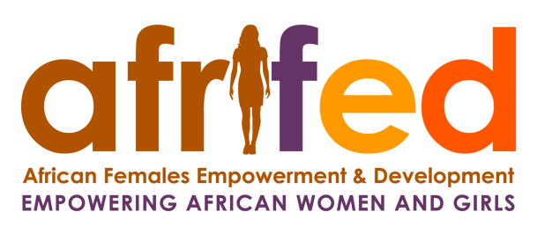

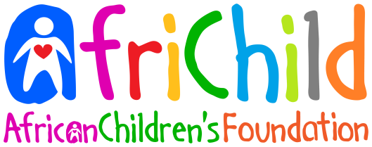

CONTEXT

Partners……………………………………………………………………………………………………………………………1

Preface…………………………………………………………………………………………………………………………….3

Introduction……………………………………………………………………………………………………………………..4

Background……………………………………………………………………………………………………………………...4

Proposal…………………………………………………………………………………………………………………………..4

Girls and Women Action Plan…………………………………………………………………………………………..5

Objective One………………………………………………………………………………………………………………………….5

Objective Two………………………………………………………………………………………………………………………….6

Objective Three……………………………………………………………………………………………………………………….6

Analysis……………………………………………………………………………………………………………………………7

Finance…………………………………………………………………………………………………………………………….7

Summary………………………………………………………………………………………………………………………….7

References……………………………………………………………………………………………………………………….8

Preface

Currently in Africa, many women and girls are restricted to traditional female roles such as being mothers of families and are not presented with the same opportunities as their male counter parts. Despite many programmes aiming to resolve this issue, Sub – Saharan Africa still depicts the world’s lowest literacy rate with 65% of their population being able to read and write in 2017. Although that figure has risen in the past decade, the majority of those who make up that percentage are men highlighting the inequality between the genders. The purpose of this document is to highlight the issues surrounding gender inequality and yet providing solutions to help empower females of all ages despite the problems they face.

This Plan of Action will involve a range of statistics from throughout the years and articles related to the topic.

The report in focus will provide a detailed analysis that highlights the effect of implementing women empowerment programmes on both socially and economically in the affected areas. It will also advocate the importance of gender equality, especially within developing countries, as it can aid many different factors within society.

Introduction

Around the world, the disparity between the genders is still very much apparent: visible in both social and economic situations. However, the difference seen in African countries is the way the female community deal with the inequality. Women lack the knowledge of what they are capable of despite the enforced discrimination and more initiatives need to be practised to empower all generations of women and allow them to realise their potential along with realising their worth.

Background

Women, especially in sub-Saharan Africa, typically have a lower literacy rate than their male counter parts: more than 12 countries in sub-Saharan Africa have a female literacy under 50%, seen in 2014, however that has been a stagnant rate for the last 20 years. Despite the economic importance of education, it also creates a sense of independence for women, so they are no longer reliant on their male counterparts. This is the main focus of this report: highlighting the importance of female independence and empowering them to achieve personal aims.

The literacy disadvantage has played a major role in the social standing of women throughout the continent of Africa. This has been displayed in places such as Malawi through the longstanding issue of ‘sex for fish’. This entails females using their bodies in order to receive fish from men for them to sell. This issue displays the social and economic hinderance the lack of knowledge has on women and their families.

Female empowerment is essential within all continents due to the systematic sexism which is seen worldwide. In 2018, it was reported that the gender pay gap would take a further 202 years to close highlighting the clear inequality. Hence why women around the world, however focusing in Africa, need to be educated on their potential and reinforce how power females can be despite the systematic challenges.

A key issue in African countries is the complacency among women surrounding traditional female roles such as being mothers or falling into the cycle of being a mother, further preventing them from working or making further economic endeavours more challenging. Many argue, ‘education is the best contraceptive’, creating a stronger initiative for the push for female education especially in Sub-Saharan Africa, where they still hold one of the highest fertility rates at 4.78 children per woman in 2017.

Proposal

This Plan of action is aligned with the AHO Strategic Plan and is based on the following recommendations:
- Train those within rural communities to be teachers
- Sharing stories of successful women to all generations of women
- Create women only centres

Girls and Women Empowerment Action Plan

Objective 1
Train older members of rural communities with basic literary and numeracy skills to educate younger girls within the community these essential primary school skills, in the comfort of their own village with those they trust.

Indicator
- In sub-Saharan Africa, 33.3 million girls of primary and secondary school age are out of school. This is a result of many factors including dangerous journeys to school and pregnancies.

Activities
  - Operating on the bases of volunteers, train those willing to teach with the basic English literacy and numeracy skills. Due to the knowledge being relatively beginners’ level, it would not require an intense training and learning programme for those willing to teach. The fundamental skill that would be required to learn from the volunteers is people management as they would be teaching other adults these skills.
  - With some extra training, the girls can also be educated in sexual health matters. This can help decrease the fertility rate especially in sub-Saharan Africa as they would more educated in the prevention of pregnancy.
  - Those volunteers would then teach older women within the communities these basic skills. Due to possible language barriers, translators may be required, however. It would also act as beneficial to teach basic English to the teachers as well as it is typically used as the language of business.
  - In order to stick with the female empowerment scheme, possibly seek a female translator highlighting possible opportunities to young girls. This objective acts a beneficial to a whole host of people including the translators, the older generation of communities and the younger girls within the communities.
  - Previous initiatives similar to this have been unsuccessful due to the fact the young girls do not retain their knowledge because it is not used – a result of factors such as pregnancy. Therefore, there has been a change in the way literacy is taught alongside practical economic skills that can be retained via jobs such as trading. This may be a more expensive programme as the training of the volunteers would have to be more complex however research shows it may act as more effective.

Objective 2
In order to emphasise the importance of women in society and highlight the possible career ventures for them, this initiative includes sessions in where young females are educated in women’s history: they learn about the achievements of other women.

Indicator
- Children tend to respond to those who look like them, therefore inspiring them with stories of powerful women can be used as a stimulant for them to aim to pursue careers.

Activities
  - This is a relatively simple initiative as it would just involve, again, the educating of older females about positive female role models in which they could relay to younger girls within the community
  - Despite this being relatively simple, it has been proven students respond to those who mirror them. Therefore, if there is an inclusion of black successful women, it could inspire them to seek further careers in specific fields.
  - This initiative could also include women professionals from countries in Africa, making the experience more personal to the specific communities.

Objective 3
Centres within rural communities can be used as safe space for women in that area. It can be a multifunctional place used for not only education but also a place where women can seek help from each other.

Indicator
- Safe havens for women can allow empowerment among each other and lead to the motivation of peers. The idea of community plays a vital role in growth and productivity.

  - The creation of the community centre maybe seen as an expensive investment due to the fact it would aim to be a free place to ensure it would not restrict anyone from attending
  - Expenditure would be focused of the actual building of the community centre and the maintaining of the facility which may be viewed as especially hard for a charitable organisation. It would also be hard to scale it on a wide scale branching all over Africa.
  - An alternative solution to the financing issue could be the introduction of weekly women meetings within the community. This would not require a specific base as women can find a secluded place for them to meet without male interference. Despite the lack of external management, it would still express the idea of creating a safe haven and enforce the idea of female empowerment from each other and reduce the dependency of women to men.

Analysis

In previous studies, it shows that the enhancement of women in empowerment, especially in Sub-Saharan Africa, acts as a successful contraceptive and decreases levels of domestic violence. This highlights the effectiveness of empowerment among women and girls as it could help prevent issues such as the ‘sex for fish’ matter.

As a whole, the objects stated would not require government intervention however it could align with many other NGOs who aim to achieve similar things. A cooperation with fellow organisations may cover the finance issue surrounding the community centres proposed.

Finances

As the programmes in focus aim to cover Africa as a whole, it is hard to calculate finances as a whole. Therefore, Chad will be used as a bases for calculations. Chad is an ideal country to focus on as in 2016, only 13,96% female literacy rate reported by UNESCO. The key expenses would stem from the creation of the female only community centres and upholding it upkeep.

When building a centre, the main expenses would come from the purchasing of the land and the electrics and plumbing of the facility. Due to location, solar energy would be seen as most efficient energy source which costs between $500 -$1000 in Sub-Saharan Africa for a typical home system in 2006. However due to inflation over the years, it would now be around $638.30 - $1,276.59 in 2019. The Chadian government has had initiatives enforced to raise primary school education rates by 2020 however with private organisation such as AHO, they are unlikely to help support the process. Therefore, funding for intuitions such as these would have to be done externally.

Other finances would come from the training of volunteers. This can be accessed for £19 from job recruitment websites. However, the cost of sending them to the countries in focus would have to be considered alongside that. To combat these costs, schemes that allow volunteers to travel and help communities could introduced as they are currently thriving in recent years. As for mentioned, the community centre is not a necessity as it is just a means to encourage communication among women therefore volunteers can also introduce that idea alongside the teaching.

Summary

The empowerment of girls and women throughout Africa is vital for economic and social growth within the countries within. Encouraging females to take control of their self-worth in countries such as Malawi can help prevent situations such as the ‘sex for fish’ wave.

AHO presents fundamental solutions to help encourage the growth of self-development of women that include the following:

- Educating girls using older women in the community to enforce the idea of female role models that they can aspire to

- Incorporate business skills alongside basic literacy and numeracy teaching to ensure knowledge is retained

- Introduce the idea of a female community where they can empower each other; sharing experiences and helping each other

- Use female professionals as role models for girls in rural communities to help create further female role models.

- Creating community centres that can be used as a haven for females

- Work alongside other female based charities in order to support and help fund communities.

The effects of the following would be to increase female confidence and introducing the idea that they can be professionals and escape poverty independently from male assistance.

References

Education is a universal right. It is also a matter of justice, Campaign for Female Education, [online], https://camfed.org/why-girls-education/

Madamombe. I, Solar power: cheap energy source for Africa, African Renewal, [online], 2006, https://www.un.org/africarenewal/magazine/october-2006/solar-power-cheap-energy-source-africa

McCoy. C, Girls’ Education in Chad Progresses after Outlaw of Child Marriage, The Borgen Project, [online], 2018, https://borgenproject.org/girls-education-in-chad-progresses-after-outlaw-of-child-marriage/

Neate. R, Global pay gap will take 202 years to close, says World Economic Forum, The Guardian, [online], London, 2018, https://www.theguardian.com/world/2018/dec/18/global-gender-pay-gap-will-take-202-years-to-close-says-world-economic-forum

Shiundu. A, More Must Happen, D+C, [online], London, 2018, https://www.dandc.eu/en/article/literacy-rates-have-risen-sub-saharan-africa-reality-probably-worse-official-numbers-suggest

Silver. M, The Dark Secret of Lake Malawi: Trading sex for Fish, Goats and Soda, [online], 2019, https://www.npr.org/sections/goatsandsoda/2019/06/28/736296041/the-dark-secret-of-lake-malawi-trading-sex-for-fish

Yaya, S., Uthman, O.A., Ekholuenetale, M. et al. Women empowerment as an enabling factor of contraceptive use in sub-Saharan Africa: a multilevel analysis of cross-sectional surveys of 32 countries. Reprod Health 15, 214 (2018)

13 reasons why girls are not in school on International Day of the Girl Child, Their World, [online], 2017, https://theirworld.org/news/13-reasons-why-girls-are-not-in-school

