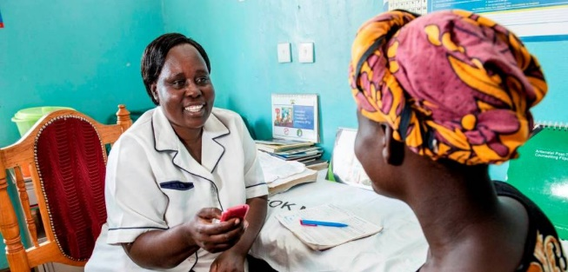

By Shumell Gul

BSc Biochemical Engineering

University College London

* Reduce premature deaths from non-communicable diseases by 25% by 2030.
* Educate communities and take a positive attitude to combat cancer at the level of individuals, community, governments and international organizations.
* Raise awareness of solutions and treatment.
* Harness efforts that aim to mobilise treatments and improve access to alleviate the burden of cancer.

AHO Mission

The number of cancer cases is steadily rising as a result of aging populations, tobacco/alcohol abuse and consumption of unhealthy foods. African nations can be particularly vulnerable due to infections of human papillomaviruses Hepatitis B/C virus that contribute to cases of liver and cervical cancers.

**Screening & Early Diagnosis**

Costs of care and treatment is significantly less if the early intervention is obtained. Visual screening for specific cancer types in a community, healthcare setting may be a more effective method of reducing the burden of late-stage cancer cases in low-income African nations.

Increasing the number of these facilities is also key to ensure accessibility to poorer families, particularly in rural locations.

Cancer mortality can be reduced if early diagnosis and intervention can be accessed, however, this is a challenge in low income countries.

**Africa Cancer Week**

**01/02/20-08/02/20**